**Kubernetes Cluster**

**What is Kubernetes?**

Kubernetes is an open-source container orchestration platform that simplifies containerized applications' deployment, scaling, and management.

**Features of Kubernetes:**

1. Container Orchestration:

Automate Deployment, Scaling, and Management of Containerized Applications.

1. Scaling
2. Self Healings
3. Portability

**Market Available Tools:**

1. Docker Swarm by Docker
2. Kubernetes from CCNA
3. Mesos from Apache

**Difference between Docker Swarm vs Kubernetes:**

a) Kubernetes is well suited for complex applications, on the other hand, Docker Swarm is designed for ease of use, making it a preferable choice for simple applications.

b) Docker Swarm provides automatic load balancing while Kubernetes does not.

c) Kubernetes has a built-in monitoring tool integration with a third party, docker swarm has no this type of feature.

d) Kubernetes provides Auto scaling while Docker Swarm provides on-demand scaling.

**How Many ways we can setup Kubernetes Cluster:**

a) Minikube:

single node cluster, used for educational purpose

Operating System: Linux, MacOS, Windows.

b) Kubeadm:

Provided by K8S

Use this approach if you want more control over the cluster configuration.

Multinode with single Master Node.

Used for Development and testing Purposes.

c) Kops(Kubernetes Operation):

deploying, managing, and upgrading production-ready Kubernetes clusters on AWS (Amazon Web Services) and other cloud providers.

d) KubeSpray:

Ansible-based tool used to deploy a production-ready Kubernetes cluster on various cloud providers or on-premise servers.

e) Rancher:

It is a fully container management platform, and Kubernetes is an option.

f) Cloud Manage Kubernetes Services: AKS, EKS, GKE.

g) High Availability Setup:

Used in a production environment

Multi-master node and multi-worker node

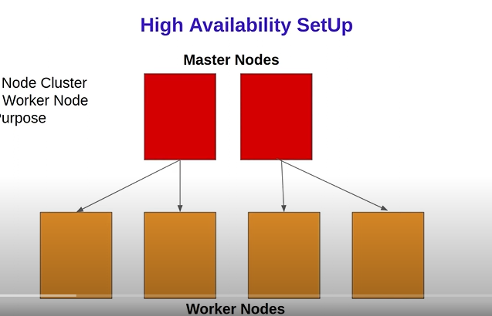

**Kubernetes Cluster:**

**a) Master Node or Control Plane Node:**

i) kube apiserver: main component or gatekeeper of an organization)

ii) kube scheduler: schedule pod on the node

iii) kube controller: node controller, replication controller.

iv) etcd: store the information of cluster in key-value format.

**b) Worker Node:**

i) kubelete: the responsibility of starting a pod.

ii) kubeproxy: forward request from service to pod

iii) CRI: docker\

[**https://devunnatig.hashnode.dev/kubernetes-overview-architecture**](https://devunnatig.hashnode.dev/kubernetes-overview-architecture)